Valentine Shepherd Series Press Kit
Table of Contents:
- Press Release
- Author Bio and Contact Info
- Author Photos
- Book Photos
- Book Cover Copies
- Awards and Testimonials
- Sample Interview Questions
- Book Experts
- Buy Links and Miscellaneous Info

Press Release, current a/o April 2017:
AMERICAN SOLDIER DOES DOUBLE DUTY AS PUBLISHED AUTHOR
From Afghanistan with love…
Despite being deployed to a war zone, U.S. military officer Shana Figueroa found time to do what other aspiring authors only dream of—write and publish two books.
While serving in Afghanistan between 2016 and 2017, Shana spent twelve hours a day working as the Security Assistance Office training branch chief, helping the country learn the skills it needs to stabilize and become self-sufficient. At night, she went back to her room and worked on her novels.
Many full-time authors don’t manage to write more than one book every few years, let alone two in one year. So how did she do it?
By treating her writing like a second career, with a strict schedule to meet a minimum word count each day. She also took every opportunity to jot down notes or bits of chapters while doing mundane things like eating lunch or waiting to get on a helicopter.
“If you write three hundred words a day, you’ll have a full-length novel within a year,” Shana said. “More than that, and you can write multiple books a year. The hard part is holding yourself accountable.”
Her genre? Romance.
Not sci-fi? Not military thrillers ala Tom Clancy? Why romance?
Stories of love and redemption have always appealed to her. Being surrounded by war in her everyday life gave her a front-row seat to the worst aspects of human nature. The experience instilled in her a deep appreciation for the power of love to make the world a better place. She’s seen it first-hand—love and compassion ultimately lead to peace.
Since romance is all about the power of love, the genre was a perfect fit.
In the heart of Kabul, Shana finished two books: RETRIBUTION, the second book in a romantic suspense trilogy, and RECKONING, the third book in the trilogy. Beginning with VENGEANCE, the series follows the love story of Valentine Shepherd and Maxwell Carressa, two people with a unique connection at the heart of a conspiracy they can only overcome by helping each other conquer their demons.
“With enough dedication, anyone can be a successful author,” she said. “I’m proof that a busy life doesn’t have to be a roadblock to achieving your dreams. If I can do it, anybody can.”
VENGEANCE and RECKONING are available now in digital and hardcopy on Amazon, Google Play, Kobo, Apple, and Barnes and Noble. RECKONING is available for pre-order and scheduled for release on July 11th 2017.
For a full press kit, go to http://www.shanafigueroa.com.
Author Bio:
Shana Figueroa is a published author who specializes in unique romance and humor, with occasional sojourns into horror, sci-fi, and literary fiction.
She lives in Massachusetts with her husband, two young daughters, and two old pugs. By day, she serves her country in the US Air Force. By night, she hunkers down in a corner and cranks out the crazy stories lurking in her head.
Connect with her at www.shanafigueroa.com.

Contact Info:
Website: http://www.shanafigueroa.com
E-mail: shanafigueroaauthor@gmail.com
Facebook: https://www.facebook.com/shanafigueroaauthor
Twitter: https://twitter.com/shana_figueroa

Author Photos:

Book Photos:
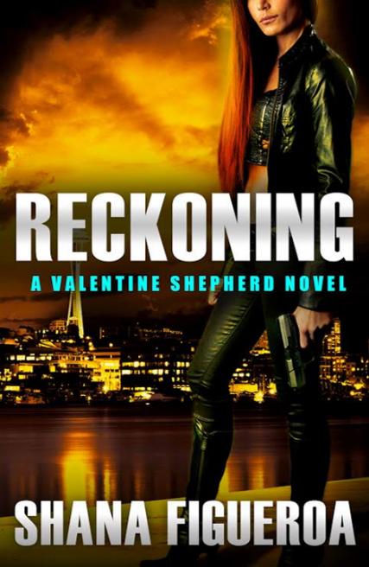
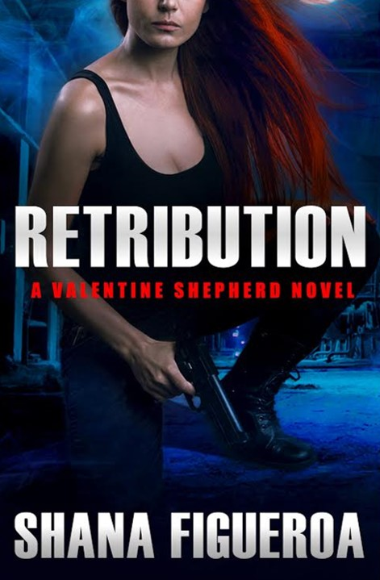
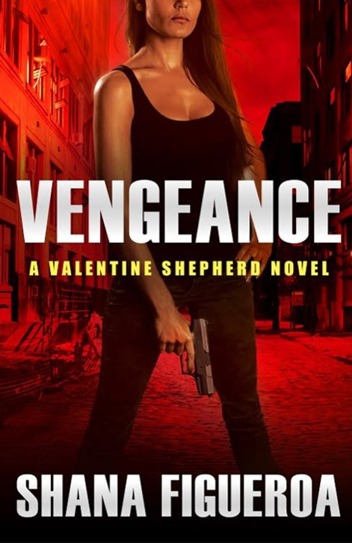

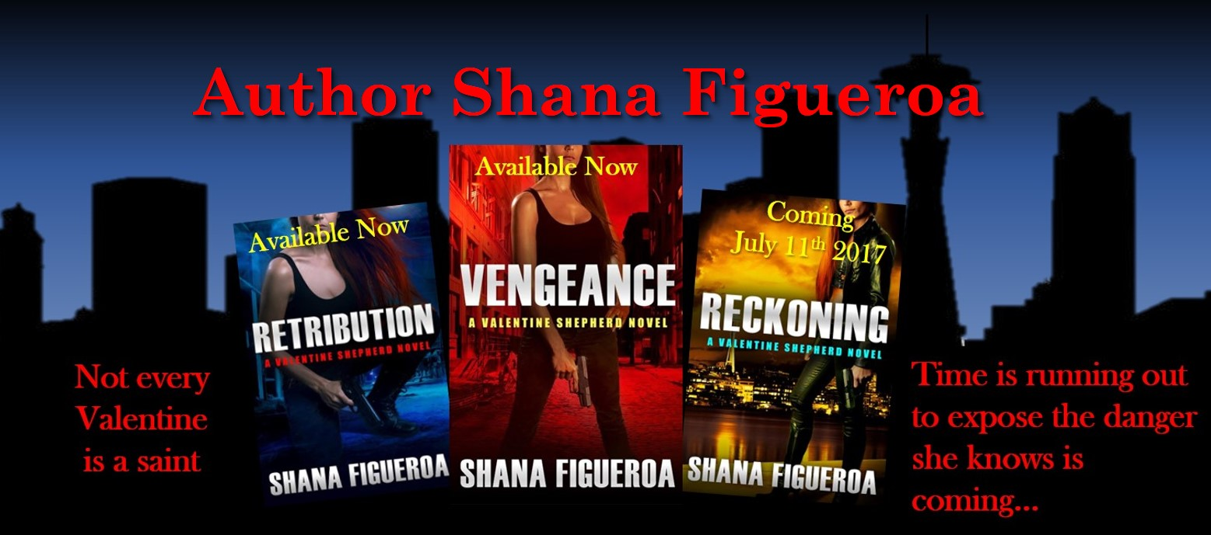
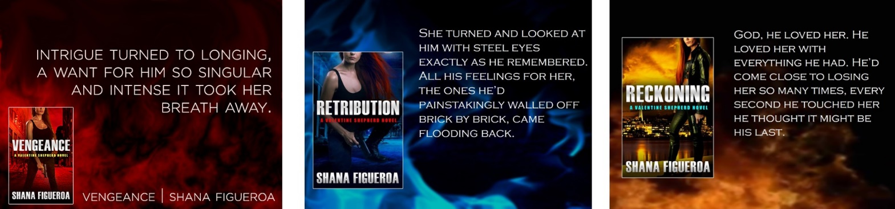
Book Cover Copies:
BOOK 1: VENGEANCE
Not every Valentine is a saint . . .
Corruption. Greed. Illicit sex. Murder. Private investigator Valentine Shepherd thinks she’s seen it all, and her strange ability to glimpse the future gives her an edge no one else in the world has. But when her fiancé is killed trying to exonerate his client, billionaire Max Carressa, Val makes it her personal mission to bring the people responsible to justice, no matter the cost. Convinced the two men are linked by more than attorney-client privilege, she enlists Max’s help in her investigation and gets more than she bargained for…
On the run, Val and Max must uncover who wants them dead and why. The answer leads them to a conspiracy that has Val herself at its center. She doesn’t understand how or why, but time is running out to expose the truth and escape the danger she knows is coming…
BOOK 2: RETRITUTION
V is for vengeance…
Private investigator Valentine Shepherd plays by one set of rules: hers. She’s haunted by dark, cryptic visions of the future, not to mention an aching hole in her chest where her heart—and the love of her life, Max Carressa—used to be. But when Val’s search for a missing woman leads to her own night of terror, the only thing on Val’s mind is revenge.
In the months since Val walked away from their relationship, Max has tried to move on. Yet when she asks for his help tracking down her attacker, he knows resistance is futile: he’ll do anything for Val. Even sacrifice himself to save her.
BOOK 3: RECKONING
Hell hath no fury like Valentine…
Five years. It’s been five years of blissful peace for private eye Valentine Shepherd and her hot-ass husband, Max Carressa. Five years of watching their twins grow up healthy and happy, even as Val waits for Hell to unleash its fury. Her enemies have been planning, and Val knows she doesn’t have nearly enough weapons to protect her family…
Yet Val and Max have one advantage—their insatiable desire for each other allows them to see into the future, and the visions they share may just give them a chance. But as events are set into motion that endanger everyone Val’s ever loved, she’ll do whatever it takes to stop the horror she’s already seen.

Awards and Testimonials:
VENGEANCE – Second Place Winner of the Romance Writers of America New England Chapter’s Readers Choice Awards for 2016
“Beautifully written. Shana Figueroa is an exciting new voice in the paranormal genre.” — Opal Carew, New York Times bestselling author
"[Vengeance] blew me away! I was literally hooked from page one until I finished it eight hours later. ...Everything about this book was fantastic. The characters, the writing, the plot, and the best part was the plot twists!" - Night Owl Romance
"...I thoroughly enjoyed this explosive story...Shana Figueroa has written a story with some awesome characters and the twists will have you wondering what's going to happen next." - Bella's Blog
"I am not going to ruin the surprise, but really in my years of reading paranormal I never came across the twist as I did in Vengeance...As the story came to a conclusion I was rendered speechless." - Cruising Susan Author Promos and Reviews
"...Vengeance was quite an interesting story to read, with thick plots that overflowed with action..." - Hoards Jumble
"Explosive action, increasing body count, all the way/around the way/any way sexual encounters. P-l-o-t. Plot. And more plot. There was a huge does of wtf, really, are you kidding me, oh no, say that again. I just can’t tell you the details. You have to read this one for yourself." - Miley the Book Junkie Reads
"I loved Val and Max and the plot had me reading long into the night. There is a lot of sex throughout, but there is a very unique reason for it. I can't wait to get the next book in this series. Unique and hot!" - The Romance Reviews
“This is only the second book in this series and it is already one of my “must read” urban fantasy series! RETRIBUTION (Valentine Shepherd #2) by Shana Figueroa gave me complex characters, a plot that continues to surprise and kick-butt action.” – Avonna Loves Genres
“I enjoyed the way the story [RETRIBUTION] played out, the twists and turns, the weaving together people who seemed not to have a connection and then….Stars: Five, a great read, and sometime I want to read book one, but for now am waiting for the final part!” – Jeannie Zelos’s Reviews

Sample Interview Questions:
Q: Tell us a little bit about yourself and what led you to start writing.
A: Throughout my entire life, I've always enjoyed writing and making up stories. One of my favorite things to do is come up with alternate storylines for movies and TV shows - especially the ones that used to be good but are on the decline and could really use some help. I didn't start writing seriously until about five years ago, when I decided to invest in a Career Plan B. So after a slow and steady build-up, I'm finally going pro!
Q: You have such an interesting background working in the Air Force! How did writing and editing the book jive with your military duties?
A: Due to the long hours I keep at my primary job, I have to do almost all of my writing in the evenings. For me, the key to finishing a manuscript is to work on it a little every day, with few exceptions. My usual quota is 300 words a day. I also have my husband to thank, since he tackles most of the child-rearing duties while I go to work and then come home and write.
Q: What was your inspiration for writing the Valentine Shepherd series? What about the main character?
A: Being a huge fan of the TV show Veronica Mars, I took inspiration from the show’s noir aesthetic and sharp sense of humor, and added a dash of the paranormal to really spice things up. I envisioned my heroine, Valentine Shepherd, as tough but also vulnerable Private Investigator, someone who's come to uneasy terms with her strange ability through a mixture of steeliness and sass. In a nutshell, Val is very much like a tougher, sexier version of Veronica Mars.
Q: What was your road to publication like?
A: In order to get published, I had to treat my writing as a second job rather than a hobby. I read a lot of how-to books to hone my craft, attended monthly writer's group meetings to get other people's opinions as well as get a feel for other styles, and went to writing conferences and workshops not only for writing advice but for info on the business and marketing aspect of the craft. When I thought I was ready, I shifted into business mode, steeled my heart for an onslaught of rejection, and started the search for a literary agent. The prep I did before I found an agent was the key to success.
Q: What is some fun promotions you have going on for this series?
A: I’ve got three big ones: 1) Sign up for my author newsletter via my website at www.shanafigueroa.com, and receive a FREE e-copy of VENGEANCE! 2) Write an honest review of one of the books in the Valentine Shepherd Series, e-mail me (shanafigueroaauthor@gmail.com) a link to the review, and receive an e-copy of the next book in the series for free! 3) Pre-order RECKONING, e-mail me (shanafigueroaauthor@gmail.com) the receipt, and receive an e-copy of both VENGEANCE and RETRIBUTION for free!

Book Excerpts:
Excerpt from VENGEANCE:
On the far end of the study a man in his late twenties stood next to a bookcase, head down as he leafed through a textbook. He wore the dark gray vest and slacks of a fine three-piece suit, the sleeves of his white dress shirt rolled up to his elbows. Thick, wavy black hair framed a Hollywood-quality face with a sharp jawline and rough-textured lips pressed together in concentration. Val heard the door close behind her as he lifted his gaze to meet hers. She’d seen him enough on the news that an introduction wasn’t necessary, but he gave her one anyway.
“Hello,” he said as he snapped his book shut, then put it back on the shelf. “I’m Max.”
“Valentine Shepherd.” The photos they used on television hadn’t done him justice. He looked even handsomer in person, she couldn’t help noticing.
Max gestured for her to sit down at a thick leather chair across from his desk. The movement exposed dragon tattoos inked in bright aquamarine colors across each of his inner forearms. As Val took a seat, she tried not to stare. They weren’t dragons, she realized, but fractal patterns, like the intricate designs on folders she’d had as a kid.
He sat across from her at the head of the desk. “Kitty,” he said to the blonde, “please bring Miss Shepherd a drink.” He looked at Val. “What’ll you have?”
“I’m fine, thanks. And call me Val.”
“Sure thing, Val.” The words rolled thick off his tongue as if he’d made a clever joke. He popped open a silver cigarette case, pulled out a joint, and held it up in front of him. Kitty sashayed over with a lighter and lit it. She went back to the periphery of the room while Max took a drag and then let out a long exhale, his hazel eyes watching the smoke drift away from him and disappear into the ceiling before snapping back to Val. His gaze pinned her down with an almost scary intelligence.
“You are not a cop,” he said. “Impersonating a police officer is a crime.”
“Yeah, but I don’t really give a shit,” Val said. “Somebody’s got to do their job. Might as well be me.”
He cracked a smile and took another puff from his joint. “I’m curious why you think Robert Price’s death was murder. I heard he was hit by a drunk driver.”
So that was why he’d let her into his inner sanctum instead of turning her away—curiosity.
“Robby was run down in broad daylight as he was about to meet an informant. That’s not a coincidence. I was there when it happened.”
“And what was he to you?”
“My fiancé.”
“You?” Max raised an eyebrow. “I wouldn’t have figured that.”
“Why not?”
“Because Robby was a bit of a dough boy.” He took another drag. “And you’re not.”
Val gritted her teeth at his backhanded compliment. Whatever Robby had lacked in the looks department compared to Max, he’d made up for in spades through compassion and warmth, something this pretty boy who might’ve murdered his own father probably wouldn’t know anything about. She forced herself to stay objective and focus on what she came for.
“Robby was meeting someone named Chet, who said he had information that could exonerate you.”
“No kidding,” Max said, and looked lost in thought for a moment.
“Do you know anyone named Chet?” she asked.
“Got a last name?”
“No. Just Chet. Might be short for Chester. Effeminate Hispanic guy, early to mid-twenties. Probably lives somewhere around South Washington Street.”
Max bit the tip of this thumb and squinted his eyes as if he were scrolling through a mental Rolodex. “Nope, I don’t know anyone named Chet or Chester who fits your description.” He looked at the blond woman. “Kitty, can you think of anyone?”
“No,” she said in a voice like black velvet.
“What about the information that Chet said he had?” Val asked, a hint of desperation creeping into her tone. “What could an anonymous person know about you that might help your case?”
Max shrugged. “I have no idea. I would help you if I could. No one is more invested in proving my innocence than myself obviously.”
Val deflated in her chair as the chances of finding Robby’s killer went from slim to anorexic. She could search every gay bar and Chinese restaurant within a ten-mile radius of where Robby died, but even with Stacey’s help, that could take weeks. The longer she went without any leads, the colder the case got. And that didn’t include the planning she needed to do for Robby’s funeral, boxing up his things, deciding what to give to whom—if she even had the option to choose since they weren’t married—and figuring out what to do with the house she couldn’t afford on her own.
Val realized she’d been staring at the tree tapestry behind Max at the same time she noticed he’d been staring at her. She blushed a little while his warm hazel eyes studied her, as if he could see into her and read her thoughts like one of his books.
“I’m sorry for your loss,” Max said. “Maybe it was just an accident. The world is cruel that way. Sometimes bad things happen to good people for no reason.”
She scoffed. “Like how your dad accidentally fell off his balcony?”
His gaze hardened but he smiled. “Yes,” he said in a tone drier than the Mojave. “Like that.”
Val stood. “I’m sorry for wasting your time. I’ll see myself out.”
He got up anyway and followed her to the door. As she approached the exit, he reached around her and grabbed the brass knob, turning it slowly before pulling the door open. Standing barely a couple inches away, she thought she felt heat radiating off him like he hid an inferno underneath his expensive suit.
She should have stepped back; she didn’t. Whatever possessed him to suddenly enter her personal space, she wouldn’t give him the satisfaction of being intimidated.
Well, not intimidated exactly. More like…intrigued. Dangerously. A moth drawn to his hidden flame. With him so close to her, she could see the five o’clock shadow spread across his jawbone, the slight chap of his lips, the light dancing off flecks of amber in his intelligent eyes. Intrigue turned to longing, a want or him so singular and intense it took her breath away. She eyed the buttons on his dress shirt and imagined slipping her hand between them, touching his flesh underneath—
“Nice meeting you, Val,” he said as he held the door open for her, voice as cool and calm as winter snow.
She blinked as if snapping out of a trance. Stepping back, she sucked in a breath after realizing she’d been holding it. He smiled, but she recognized it as a practiced fake. Everything about his demeanor spoke of careful control—everything except the fire she felt in him just below the surface, one that threatened to consume her as well.

Excerpt from RETRIBUTION:
As she used her fingers to smooth out her hair in the window’s reflection, a figure appeared behind her. She turned and saw him standing there, the first time she’d seen him in the flesh in almost eight months. He wore jeans and a T-shirt that looked loose enough to be comfortable but tight enough to show off his toned muscles and browned skin from an abundance of outdoor exercise. Running and boxing were his sports, she remembered. His tan made the gorgeous blue and green fractal tattoos snaking across both his inner forearms stand out even more. A day’s worth of stubble shadowed his sharp cheekbones. The wavy black hair cropped short along the sides and longer on top caught the afternoon sunlight in a way the cameras couldn’t relay.
Val’s mouth watered against her will. Looking good was the best revenge—against her. Dammit.
She sat up straight and pushed away the image of what she knew he looked like underneath his clothes. “Hi,” she said with a polite smile.
“Hi.” Max didn’t return her smile. He regarded her with a neutral expression—the mask he often wore to hide his feelings. Despite his passive face, his beautiful hazel eyes with their emerald green centers—the ones that could melt her from the inside—had a cold veneer. He sat in a chair across from her, leaned back, and crossed his arms over his chest like a shield.
Val pushed back a lump in her throat. He clearly didn’t want to be there, with her. She wouldn’t keep him long.
“How are you?” she asked, though if the press reports were accurate, she knew the answer was “fabulous.”
“Fine,” he said. “You?”
“Uh, I’m—” Terrible. She pulled at her hair, making sure it covered her scar. “You look good.”
His voice was flat. “You, too. What do you want, Val?”
What she wanted was him. No matter how much she tried to convince herself otherwise, she still loved him. She loved him so much it filled her entire being and poured out of her in waves of desperate longing so strong she was surprised Max hadn’t drowned in it yet. But she’d broken his heart. She loved him, and he hated her. He was better off without her.
She sipped her coffee, taking a moment to get her emotions under control, then asked, “Have you ever been to the Pana Sea?”
“A few times.”
“Are you a regular?”
“No. Too many people for my taste.”
“Oh.”
Val swallowed hard and put her trembling hands in her lap so he couldn’t see them. Max began fidgeting with the hem of his shirt, his cool resolve waning as his eyes cast about, looking at everything besides Val. What they’d been through—what she’d put him through—had been a roller coaster ride of emotions most people wouldn’t experience over their entire lifetime, let alone a few months. She’d hurt him deeply when she left; she knew that. The quicker she left him alone now, the better.
“Have you ever met a man named Lucien at the Pana Sea?”
Max’s gaze cut back to hers, and he raised an eyebrow. “Lucien Christophe?”
“Maybe. Frenchman, blond hair, late thirties or early forties?”
“Yeah, that’s him.”
“What do you know about him?”
Max shrugged. “Nothing, really. He’s in pharmaceuticals. When I was on the board of Carressa Industries, we sold him a small company that manufactured lab equipment. Now I see him sometimes at charity fund-raisers. Why do you ask?”
“I think he might be involved in a woman’s disappearance.”
His brow furrowed. “Who?”
“Her name is Margaret, but she goes by Celine at the Pana Sea. She works as an escort. She’s going to die soon, if she’s not dead already.”
Max sat up in his chair, a deep frown etched on his face. “You saw it in a vision?”
Val nodded.
“And you think you can stop it?”
“I’m going to try. I have to try.”
His face darkened.
“Lucien’s part of a club called the Blue Serpent. Have you heard of them?”
“Yes.” He started tapping his toe, his outer cool continuing to disintegrate.
“Are you a member?”
“No. I’ve only heard other people talking about it. Sounds more like a cult than a club.”
“Can you get me access?”
Max scoffed. “That’s why you asked me to come here? You want me to join a cult for you?”
“Only rich people can get in. You’re my only rich…friend.”
He glared at her. They would never be just friends. Either they’d be lovers or nothing at all.
“I’m not joining a cult,” he said.
“Then introduce me to someone who’s already in it.”
“No,” he snapped. “I’m not setting you up on a blind date with a cult member, either. I don’t want any part of this.” He stood to leave.
“Max, please.” She grabbed his arm before he could walk away. A pulse like static electricity shot through her at the feel of his flesh. He glanced at her hand, then at her, and for half a second Val saw her Max looking back, the one that set her insides on fire, that wanted her as much as she wanted him. Just as quickly he disappeared. After she’d caught her breath, Val said, “Margaret will die if we don’t do something.”
“That’s great you’re willing to bend over backwards to change the future for someone you don’t even know. Congratulations on finding something important enough in your life to fight for. Good luck with that.”
He didn’t jerk his arm out of her hand, but he walked away with such purpose that he left her arm dangling in the air, grasping at his receding back, blurry through her tears.

Excerpt from RECKONING:
Val sat at the foot of the bed, sipping coffee and watching Max futz with a tie in front of the bedroom mirror. From the first floor, Lydia’s laughter reached them through their closed door. Hopefully that meant the kids were already warming up to Jamal.
“You’ve never heard of a group of guys who go to a secret smoking room or possible sex club after work, have you?” she asked.
Max’s hands stopped. He looked at her through the mirror, an eyebrow cocked. “You’re kidding, right?”
“Is that a no?”
“Yes, that’s a no.”
Thank God. She probably wasn’t dealing with an evil sex-slash-faith-healing cult again. Chances seemed slim, anyway.
He continued knotting the purple silk around his neck. “Is this related to Lacy Zephyr’s visit a couple days ago?”
“Maybe. Yes.” She’d told him Lacy came by, but had kept the details to herself out of respect for her first client in about half a decade. Now she realized she couldn’t get Max’s help without bringing him fully on board. She’d tried keeping him in the dark once before, during her investigation into Blue Serpent; it had turned out disastrously for them both. The specter of Lacy’s disapproval could take comfort that Max was good at keeping secrets. “How well do you know her husband?”
“Aaron? Not well. I see him at meetings sometimes.”
“So you don’t know what he does in his spare time, say after work?”
“No idea.”
She regarded him over the rim of her mug, drumming her fingers on the sides of the ceramic.
Max straightened his tie, glanced at her in the mirror, and frowned. “Don’t even ask.”
“Please?”
“No. Aaron and I aren’t friends.”
“But you could be.” Lord knows he could use more friends. Of course he could say the same thing about her, especially since Stacey took off five years ago for destinations unknown, but this wasn’t about her.
“I’m not palling up with someone I barely know just to find out what he does after work.”
“Okay, fine.” She took another slurp of her coffee. “Could you at least find out what his schedule looks like over the next week or so?”
Shoving the end of the tie under his vest, he turned to face her and shook his head.
“Then I’ll have to spend all day and night staking him out. Don’t know how long that’ll go on for. When my mom comes to visit in a couple days, you’ve got it covered, right?”
Max’s gorgeous hazel eyes drilled into her, his lips tightened in a half-smile. Hot damn, never had bemused frustration looked so sexy. She loved twisting his screws just to get that look.
“To state the obvious, you are manipulative,” he said as he snatched his suit coat off a loveseat in the corner and slipped it on. “I’ll see what I can do, alright?”
She jumped up and kissed him, careful not to slop coffee on his suit. “Thanks. You can punish me later.”
“You bet I will.” He slapped her ass and seized her lips with his, kissing her with such force she thought he might throw her on the bed and make love to her right then. When his kiss turned her insides to liquid and she started pulling at his belt buckle, a feverish desperation for him burning in her belly, he pulled away, stepped past her, and bounced down the stairs.
She gasped, the void where he used to be like a splash of cold water to her face. “Tease,” she called after him.
He snickered the rest of the way to the first floor. Yeah, real fucking funny. She’d make him pay for that. He wouldn’t be getting any sleep tonight, that’s for damn sure.

Buy Links and Miscellaneous Info:
VENGEANCE:
ISBN: 1455567493
ASIN: B01FD96JNE
Publisher: Forever Yours, Hachette Book Group
Release Date: September 6, 2016
Length: 336 pages
Prices: $4.99 e-book/$19.99 paperback
Buy Links:
Amazon: https://www.amazon.com/s/ref=nb_sb_noss_2?url=search-alias%3Daps&field-keywords=vengeance+by+shana+figueroa
Apple: https://itunes.apple.com/us/book/vengeance/id1112075379?mt=11
Kobo: https://www.kobo.com/us/en/ebook/vengeance-117
Google Play: https://play.google.com/store/books/details/Shana_Figueroa_Vengeance?id=dM0iDAAAQBAJ
Barnes and Noble: http://www.barnesandnoble.com/w/vengeance-shana-figueroa/1124064273?ean=9781455567492
RETRIBUTION:
ISBN: 1455567507
ASIN: B01GQIYAMS
Publisher: Forever Yours, Hachette Book Group
Release Date: February 7, 2017
Length: 368 pages
Prices: $4.99 e-book/$19.99 paperback
Buy Links:
Amazon: https://www.amazon.com/Retribution-Valentine-Shepherd-Shana-Figueroa-ebook/dp/B01GQIYAMS/ref=sr_1_1?ie=UTF8&qid=1483375122&sr=8-1&keywords=RETRIBUTION+by+shana+figueroa
Apple: https://itunes.apple.com/us/book/retribution/id1122049750?mt=11
Kobo: https://www.kobo.com/us/en/ebook/retribution-147
Google Play: https://play.google.com/store/books/details/Shana_Figueroa_Retribution?id=hnlODAAAQBAJ
Barnes and Noble: http://www.barnesandnoble.com/w/retribution-shana-figueroa/1124064168?ean=9781455567508
RECKONING:
ISBN: 1455567515
ASIN: B01MFI23TF
Publisher: Forever Yours, Hachette Book Group
Release Date: July 11, 2017
Length: 338 pages
Prices: $4.99 e-book/$19.99 paperback
Buy Links:
Amazon: https://www.amazon.com/Reckoning-Valentine-Shepherd-Shana-Figueroa/dp/1455567515/ref=sr_1_1?ie=UTF8&qid=1489299102&sr=8-1&keywords=Reckoning+by+shana+figueroa
Apple: https://itunes.apple.com/us/book/reckoning/id1173404181?mt=11
Kobo: https://www.kobo.com/us/en/ebook/reckoning-53
Google Play: https://play.google.com/store/books/details/Shana_Figueroa_Reckoning?id=bO9zDQAAQBAJ
Barnes and Noble: http://www.barnesandnoble.com/w/reckoning-shana-figueroa/1125091787?ean=9781455567515http://www.barnesandnoble.com/w/reckoning-shana-figueroa/1125091787?ean=9781455567515

